NATIONAL BEGONIA SOCIETY
NATIONAL SHOW

BLOOMS SOLIHULL Garden Centre

3rd – 4th September 2011

ENTRY FORM
Name (Mr/Mrs/Ms
Address
Post Code |  | Tel No

CLASS | ENTRY | CLASS | ENTRY | CLASS | ENTRY
1 |  | 14 |  | 27
2 |  | 15 |  | 28
3 |  | 16 |  | 29
4 |  | 17 |  | 30
5 |  | 18 |  | 31
6 |  | 19 |  | 32
7 |  | 20 |  | 33
8 |  | 21 |  | 34
9 |  | 22 |  | 35
10 |  | 23 |  | 36
11 |  | 24 |  | 37
12 |  | 25
13 |  | 26

I wish to enter the above classes and agree to abide by the Society and Show Regulations.

Signature Date 2011

The completed form should be returned to
Jeff Rhodes, 7 Tew Street, Wakefield, WF2 8DR. Tel: 01924 217579.
Mob: 07789147261 Email: rhodesjeff@blueyonder.co.uk

And should arrive by Noon on Tuesday 30th August 2011

LATE ENTRIES WILL ONLY BE ACCEPTED SUBJECT TO SPACE BEING AVAILABLE

8

The National Begonia

Society

National Show Schedule

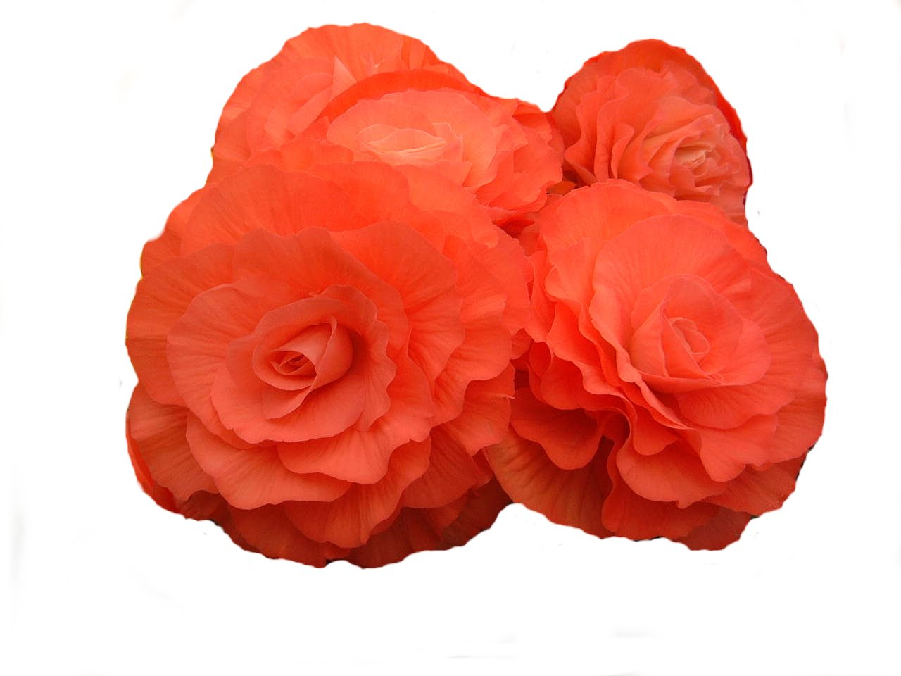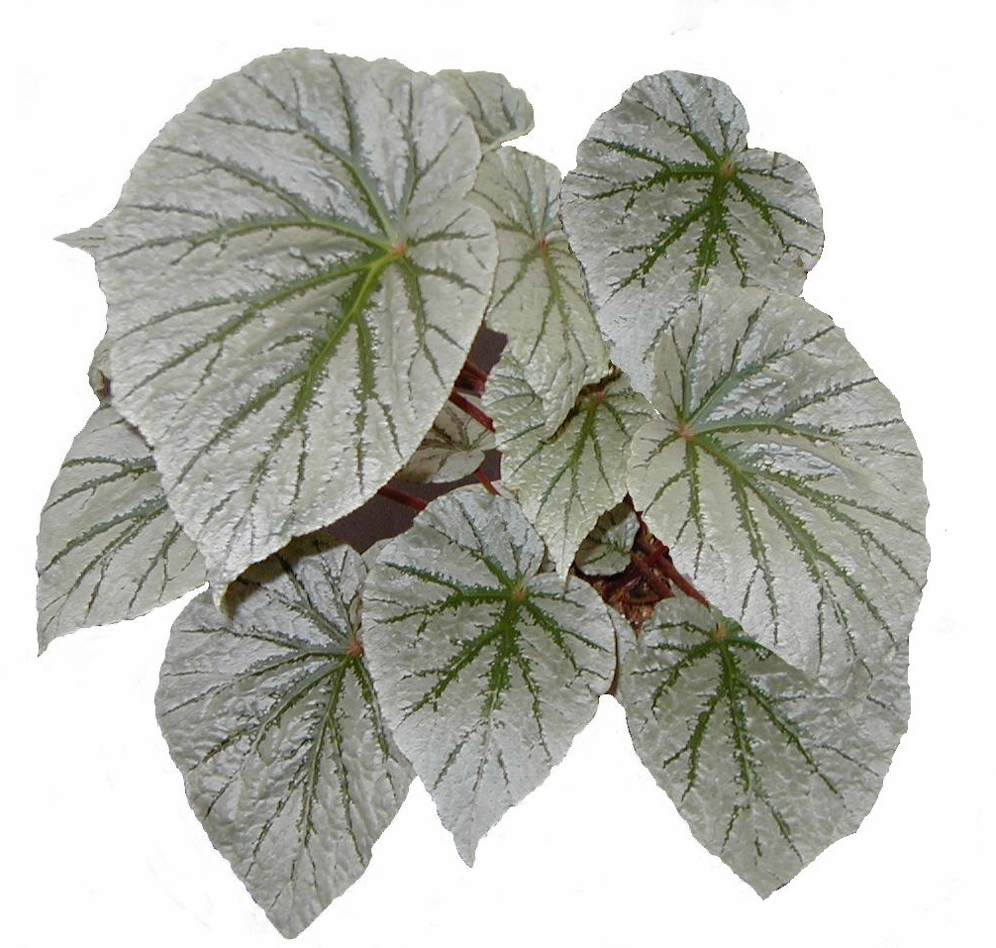

To be held at
Blooms Solihull Garden Centre
Kenilworth Road
Hampton in Arden
Solihull
B92 0LP
(By kind permission)

3rd – 4th September 2011

THE NATIONAL BEGONIA SOCIETY
NATIONAL SHOW
2011
Show Secretary: Jeff Rhodes, 7 Tew Street Wakefield. WF2 8DR.
Tel: 01924 217579 Mob: 07789147261
Show Treasurer: G.B Rushforth, 24 Gracemere Cres, Hall Green, Birmingham. B28 0TY

JUDGES: Messrs A Bryce, A Harris & G. Thompson (SBS)

REGULATIONS
Judging will be according to NBS rules.
Exhibitors may stage their exhibits between 2.00pm and 5pm on Friday 2nd. September and from 9am to 11.45am on Saturday 3rd. September.
All surplus plant material, packing material etc. must be removed by 11.45am on Saturday 3rd. September.
No unauthorised person will be allowed in the show area whilst judging is in progress on Saturday i.e. from 12 noon until judging is completed.

Judges’ decisions are final. Any protest must be lodged in writing with the Show Secretary by 2.00pm on Saturday 3rd. September.
There will be no limit to the number of entries and prizes won by any exhibitor in any class, but where an exhibitor has more than one entry in a class; points will only be awarded to the highest placed exhibit.
The society will provide boards for the cut bloom classes. Adhesive labels must not be stuck on the boards; Exhibitors must use the NBS name sheets provided.
Plants in the Pot Plant Classes may be raised up off the staging provided, using unobtrusive supporting objects, but only to ensure that the foliage can rest safely clear of the staging or to balance the exhibit.

No external embellishments such as cloth around the pots will be permitted.

With exception to classes 1 and 2, plants should not be "staged for effect", they will be judged as individual Pot Plants.
All Exhibits must carry an Exhibitors Card, and must be correctly named.
If unknown, this must be stated “UNKNOWN”
Any plant showing disease or pest infestation will be removed from the show.
The organisers of the show will make careful arrangements for the protection of all exhibits, but cannot be answerable or responsible for any loss or damage to exhibits.
No exhibit / part-exhibit / or prize card may be removed before 3.30pm Sunday 4th. September.
All trophies are PERPETUAL and must be returned to the Show Secretary by the date of the AGM in April 2012.
The National Begonia Society reserves the right to withhold the award of any of the prizes or trophies.

Presentation of trophies, etc. will take place at 2pm on Sunday 4^{th.} September.

2
* * SEEDLING CLASS * *
Class 37 | THE NBS SEEDLING AWARD
Judged by the Society Floral Committee, will be as follows: -
One un-named new cultivar of begonia in flower and in a pot of no greater than 8” (200mm) in diameter. The plant must be grown by the raiser (hybridiser), who must be a society member, an amateur, and normally entered by the raiser, though exceptionally the Secretary may permit the raiser to nominate another member who may enter the plant in the raiser’s name.
Members may submit more than one entry for this award.
A cash prize of £20 and a diploma may be awarded at the judge’s discretion.

* * * * * * *

The Egerton Vase

Will be awarded to the exhibit of most merit in the Show

The A Noakes Trophy
& NBS Bronze Medal

Will be awarded to the Best Pot of Tuberous Double Begonia in the Show.

* * * * * * *
The Alf Lewin Memorial Trophy
& NBS Bronze Medal

Will be awarded to the Best Cut Bloom of Tuberous Double Begonia in the Show

* * * * * * *

An NBS Bronze Medal

Will be awarded to the Best Pot Plant Other Than Tuberous Double Begonia in the Show

7
S Longshaw Memorial Shield
Class |  |  |  | 1st |  | 2nd |  | 3rd
The John Bagshaw Trophy

32 | Three Pots of Tuberous Double Begonias. |  |  |  | £25 | £15 |  | £10
33 | One Pot of Tuberous Double Begonias. |  |  |  | £10 | £8 |  | £5
34 | Three Cut Blooms of Tuberous Double Begonias. |  |  |  | £5 | £3 |  | £2
35 | One Cut Bloom of Tuberous Double Begonia. |  |  |  | £3 | £2 |  | £1
36 | One Pot of Begonia Other than large tuberous double |  |  |  | £4 | £2 |  | £1
Will be awarded to the exhibitor with most points in the intermediate classes.
Points awarded as follows

 | Classes 25, 27 and 30 | 4 | 3 | 2
 | Classes 26,28,29 and 31 | 3 | 2 | 1

* * * * * * *
* * NOVICE CLASSES * *

A Novice is someone who has not won more than 5 first prizes at NBS national shows prior to current season.
.

The Alf Lewin Trophy

Will be awarded to the Exhibitor with the most points in the Novice Classes.
Points awarded as follows:

 | Classes 32 and 34 | 4 | 3 | 2
 | Classes 33, 35 and 36 | 3 | 2 | 1

6
Organised by the National Begonia Society.
Open to Members of the National Begonia Society Only.

* * MAIN CLASSES * *
Class |  | 1st | 2nd | 3rd | 4th

The Sidney Longshaw Trophy
1 | Large Group of Begonias in pots, hanging containers etc.  Ferns may be used. To be staged for effect.  A bench space of 2.4m wide by 1.2m deep, 0.3m high, with a backcloth will be provided. Exhibitors may provide their own tiering. One or Two members can enter jointly. Points to be shared. | £80 | £50 | £40

The Eric Catterall Trophy
2 | Small Group of Begonias in pots. No hanging containers or any other plant material will be permitted. To be staged for effect. A bench space of 1.2m wide by 1.2m deep, 0.3m high, with a backcloth will be provided. Exhibitors may provide their own tiering. One or Two members can enter jointly. Points to be shared. | £60 | £40 | £30 | £20

The British Championship & the Fred Martin Trophy

3 | Seven Pots of Tuberous Double Begonias.  Exhibitors will be provided with one shelf 300mm (12in) high at the rear of the staging. | £120 | £100 | £85 | £70
4 | Three Pots of Tuberous Double Begonias. | £15 | £10 | £6
4 | Three Pots of Tuberous Double Begonias | £50 | £30 | £20
5 | One Pot of Tuberous Double Begonia | £15 | £10 | £7
The Allan Clarke Trophy
6 | Six Pots of Tuberous Double Begonias.  Plants to be grown in pots of diameter no greater than 18cm or of volume no greater than 3L. Plants to be grown as one main stem, and side shoots to be clearly visible above the compost. | £60 | £40 | £30 | £20
7 | One Pot of Tuberous Double Begonia to be grown as in Class 6 | £15 | £10 | £7
8 | One Pot and one Cut Bloom of Tuberous Double Begonia. Must be of the same cultivar. | £15 | £10 | £7

3

The National Society Championship & The J. Munson Trophy

9 | Twelve Cut Blooms of Tuberous Double Begonias,  Not less than eight distinct cultivars. | £80 | £60 | £40 | £30

10 | Six Cut Blooms of Tuberous Double Begonias,  Not less than three distinct cultivars | £20 | £15 | £8
11 | Three Cut Blooms of Tuberous Double Begonias,  Three distinct cultivars. | £8 | £5 | £4
12 | Three Cut Blooms of Tuberous Double Begonias,  Red and/or crimson. | £8 | £5 | £4
13 | Three Cut Blooms of Tuberous Double Begonias,  Pink and/or salmon. | £8 | £5 | £4
14 | Three Cut Blooms of Tuberous Double Begonias,  Orange and/or yellow. | £8 | £5 | £4
15 | Three Cut Blooms of Tuberous Double Begonias,  White and/or Cream. | £8 | £5 | £4
16 | Three Cut Blooms of Tuberous Double Begonias,  Picotee and/or bi-colour. | £8 | £5 | £4
17 | One Cut Bloom of Tuberous Double Begonia. | £6 | £4 | £3

C A Sothers Trophy
18 | One hanging container of Begonias. | £20 | £15 | £8

The Blackmore & Langdon Trophy

Will be awarded to the Exhibitor with the most points in Classes 1 – 18

Points awarded as follows:
 | Class 3 | 9 | 6 | 4 | 3
 | Classes 2, 6 and 9 | 6 | 4 | 3 | 2
 | Classes 4, 8, 10 and 18 | 4 | 3 | 2
 | Classes 5, 7, 11 – 17 | 3 | 2 | 1
 | Class 1 | 6 | 4 | 3

4
Class |  | 1st | 2nd | 3rd
19 | Three Pots of Begonia - Rex and/or Rhizomatous | £45 | £30 | £20
20 | One Pot of Begonia - Rex or Rhizomatous | £15 | £10 | £7
21 | Three Pots of Begonia - Cane and/or Shrub | £30 | £20 | £10
22 | One Pot of Begonia - Cane or shrub | £15 | £10 | £7
23 | Three Pots of Begonia other than large tuberous double and those scheduled above | £25 | £15 | £10
24 | One Pot of Begonia other than large tuberous double and those scheduled above | £10 | £8 | £5

The Fred Bedson Cup and NBS Bronze Medal
Will be awarded to the Best Exhibit in classes 19 to 24

The Alf Potty Trophy
Will be awarded to the Exhibitor with the most points in Classes 19 – 24
Points awarded as follows
:
 | Classes 19,21 and 23 | 4 | 3 | 2
 | Classes 20, 22 and 24 | 3 | 2 | 1

* * * * * * *
* * INTERMEDIATE CLASSES * *

An Intermediate exhibitor is someone who has not won more than 5 first prizes at intermediate and/ or open classes at NBS national shows prior to current season

The Sam Harris Cup |  | 1st | 2nd | 3rd
25 | Three Pots of Tuberous Double Begonias.  . | £35 | £20 | £10

26 | One Pot of Tuberous Double Begonia. | £15 | £10 | £7
27 | Six Cut Blooms of Tuberous Double Begonias. | £15 | £10 | £7
28 | Three Cut Blooms of Tuberous Double Begonias. | £7 | £5 | £3
29 | One Cut Bloom of Tuberous Double Begonias. | £5 | £3 | £2
30 | Three Pots of Begonias other than large tuberous double | £20 | £15 | £8
31 | One Pot of Begonia other than large tuberous double | £10 | £8 | £5

5

